|  |  |
| --- | --- |
| wordml://eCp4640_eCopy-DCM_master_Pic1.png | **RECLAMATION DISTRICT 900**  *Post Office Box 673 West Sacramento, CA 95691 PH: (916) 371-1483 •* [*email: admin@rd900.org*](mailto:email:%20admin@rd900.org) |

**RECLAMATION DISTRICT 900**

**MEETING CANCELLATION NOTICE**

Please be advised that the July 15, 2021, regular meeting of Reclamation District 900 has been cancelled.

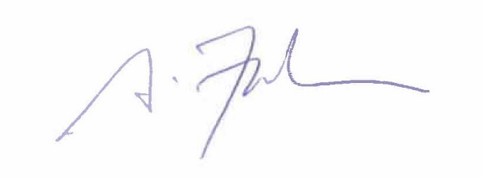I, Greg Fabun, Interim General Manager/Secretary, declare under penalty of perjury that the foregoing cancellation notice for the July 15, 2021, meeting of Reclamation District 900 was posted on July 9, 2021, in the office of the City Clerk of the City of West Sacramento, 1110 West Capitol Avenue, West Sacramento, CA, and at the office of Reclamation District 900, 1420 Merkley Ave., Suite #4, West Sacramento, CA, and was available for public review.

Greg Fabun, Interim General Manager/Secretary

Reclamation District 900